Ideation Phase
Define the Problem Statements
Date | 25 June 2026
Team ID | Not Given
Project Name | Rising Waters
Maximum Marks | 2 Marks

Team Members | Skill Wallet Team ID’s | Roll Numbers (College: ACET)
Mohana Deepika Kancherla (Team Leader) | SWUID2026226898 | 23MH1A0596
Flora Disowja Sarugolu | SWUID2026212008 | 24P35A0549
Santhi Illa | SWUID2026212021 | 24P35A0550
Mathan Bhavesh Hari Raghava Krishna Munaga | SWUID2026212007 | 24P35A0532

Customer Problem Statement Template:

Current flood forecasting methods often fail to provide timely and accurate warnings, increasing the risk of loss of life and property. A machine learning-based flood prediction system is needed to deliver reliable early warnings and support effective disaster management.

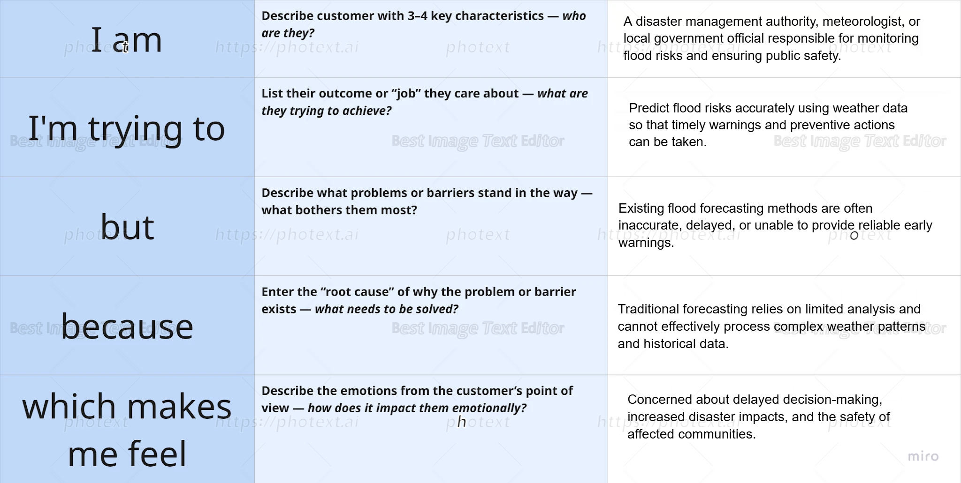
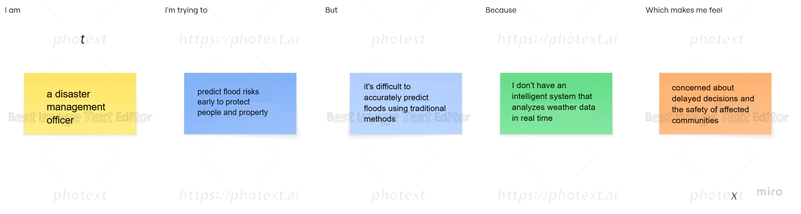
Problem  Statement (PS) | I am  (Customer) | I’m trying to | But | Because | Which makes me feel
PS-1 | a disaster management officer responsible for public safety | issue timely flood warnings and coordinate evacuations | it's difficult to predict floods accurately using traditional methods | I don't have an intelligent system that analyzes weather data effectively | concerned about delayed responses and loss of lives and property
PS-2 | a meteorologist monitoring weather conditions | provide accurate flood forecasts to authorities | weather patterns are complex and difficult to analyze manually | existing forecasting methods have limited predictive accuracy | frustrated about inaccurate predictions and public safety risks
PS-3 | a government disaster response coordinator | allocate emergency resources to high-risk areas before flooding occurs | it's difficult to identify which regions are most vulnerable | flood risk information is not available in real time | overwhelmed and worried about inefficient resource distribution
PS-4 | a local government official responsible for disaster preparedness | protect communities by making informed decisions before floods | existing warning systems often provide delayed or insufficient alerts | there is no reliable machine learning-based flood prediction system | anxious about community safety, infrastructure damage, and economic losses

